The Three Hole Bottle Demonstration
Observation & Inquiry Activity

Timeline: 30 minutes for class demonstration. Students complete final write-up as homework. If you do the optional individual investigation, another class period will be required.
AVID Methodologies Used: • Writing ‘Inquiry • Collaboration
Recommended Precursor Activities: Observation Activity
Concept Statement:
Students have the opportunity to make predictions, test hypotheses and get wet all in one easy to do demonstration. Students go through the process of making tentative predictions, testing and revising their own predictions. They will be introduced to the concept that scientific knowledge is uncertain, tentative and subject to revision. This exercise can also encourage students to ask questions, and to be responsible for their own knowledge rather than relying on the teacher.
How to orchestrate the lesson:
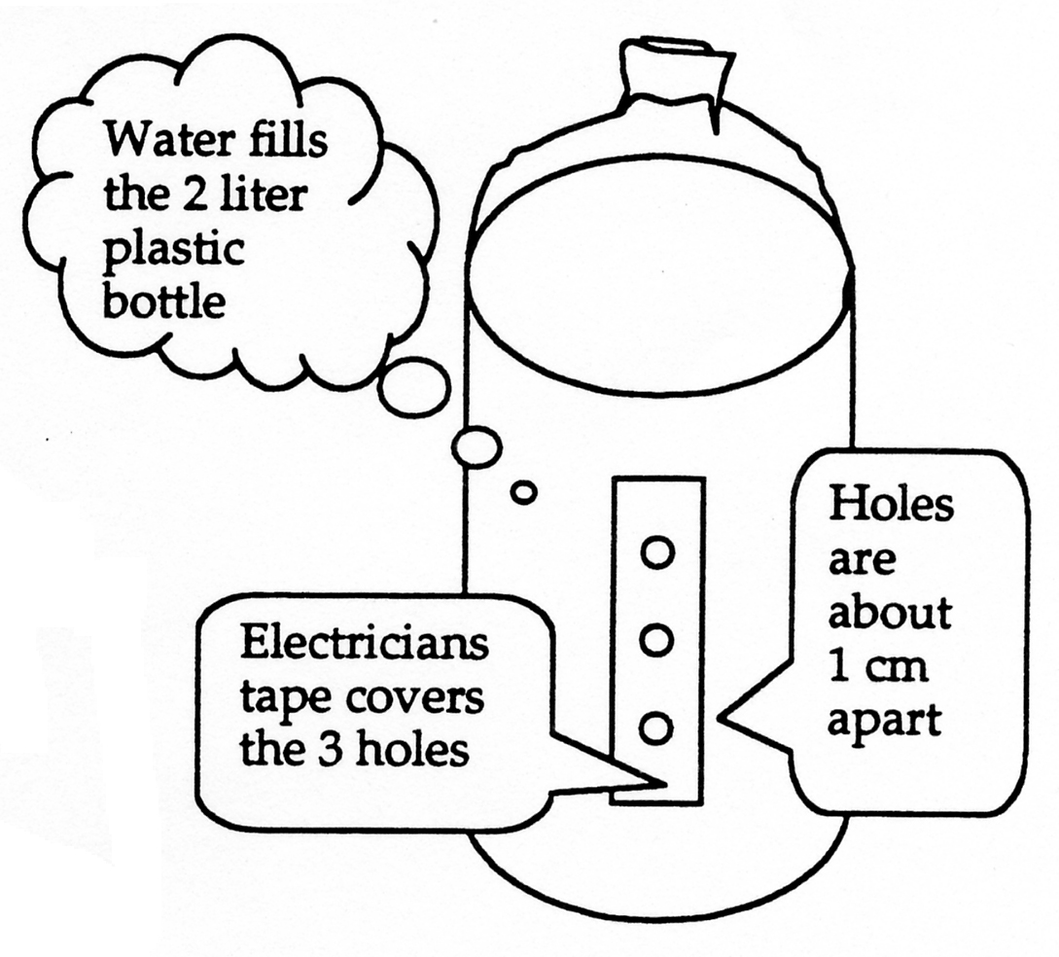
1. Duplicate one Demo Report form for each student. Make the Demo bottle using an empty, clean 2-liter soda bottle. Heat a stirring rod or triangular file with a Bunsen burner and bum 3 small holes vertically placed and evenly spaced (approximately one cm apart) on the bottle’s side. Cover the holes with electrician’s tape (it’s waterproof) then fill the bottle with water and cap it. Other materials required are a bucket and paper towels. (See diagram below)

- The teacher (to make the most impact) stands on the demonstration table, and shows the students the 3 hole bottle. Answer any questions about the bottle. Have students preview their papers, and make their initial observations and sketches.

2. Teacher: “I am going to uncover the first hole. (Have students write predictions about what will happen). “ Silently, write on your demo report paper what you think will happen when I do this.” Make sure everyone has predicted an outcome.
Teacher: We call these hypotheses in science.
Teacher: What type of thinking did you have to do to write a hypothesis? Doing science really is about indulging your curiosity about the physical (natural) world by asking questions and making predictions, and then testing them out.

3. Teacher: Ask the class for their predictions without giving your judgment, approval or disapproval. Have students use the if...then format as explained on their papers. Have at least 10-15 students read their predictions. Someone will say, “Nothing will happen” — ask that person to stand under the bottle while you uncover the first hole. Scientists often test out their hypotheses on themselves first!

4. Teacher: Uncover the first hole (try not to squeeze the bottle or you will influence the outcome). Students compare the results to their prediction and record what actually happened. *Have the bucket ready to catch some water. Have students observe then draw the path of the water.
Ask: Why do experimenters frequently use drawings to document their observations?

5. Teacher: Repeat the procedure for the next two holes - have the bucket ready to catch some water! Allow students time to write their hypotheses using the If.. .then.. .format. Anyone under the second or third hole when it’s uncovered will get wet!

6. Students: Record their predictions and data. Teacher: Repeat the procedure with the bottle held horizontally, holes facing down. This time, no water exits any of the 3 holes. This discrepant event will raise questions. Answer any question with another one... ask, what do you think? Students will ask for ‘the right answer’. Do not indulge them! The idea here is for students to do their own inquiry and observation. Questions too easily answered are no longer interesting.

7. Teacher: Discuss how the nature of science (tentative hypothesis with experimentation) allows us to revise our ideas about physical events. Refining our experimentation leads to better explanations (models) of the phenomena.
8. Optional Activity: Invite students to make their own bottles, and place their own holes in the bottle. Then do a more formal lab write-up with drawings, experimental design, graphs and analysis. The lab report format provided with this guide could be used. Have students provide the bottles. You provide the Bunsen burners, files and tape. When students complete their experiments, have them “publish” the results by holding a class water bottle symposium. It is recommended that this activity take place during warm weather, and the bottle testing be done over a lawn.
Project Requirements & Rubrics:
Students will turn in their completed Demo Report hypotheses and sketches. Check for completeness, and evidence of student thinking about how they developed their hypotheses. Student generated questions can lead to further optional experimentation and a classroom bottle symposium (students sharing their experiments) if desired.
Three Hole Bottle Demo Report
Making Predictions and Hypothesis Writing

Look carefully at the set-up. Listen as your teacher describes the bottle and its contents. Today you will practice hypothesis writing. This specialized form of prediction follows some rules - most hypotheses are written using an If...then format. For example, if a bull dog growls, then it will bite within one minute. Hypotheses can be supported or not supported by doing experiments.

1. Sketch the bottle and show the approximate location of the holes & tape. Make any other observations about the bottle now.

2. Make a hypothesis about what will happen when your science teacher pulls the tape from the first hole. Use the if...then format. Then sketch how the bottle will look and the path you think the water will take.

IF:

THEN:

3. Record the experimental results - sketch how the bottle
actually looked. Include the path of the water also.

4. Make a hypothesis about what will happen when your science teacher pulls the tape from the SECOND hole. Sketch how the bottle will look and the path of the water

IF:

THEN:

5. Record the experimental results - sketch how the bottle actually looked.

6. Make a hypothesis about what will happen when your science teacher pulls the tape from the THIRD hole. Sketch how the bottle will look.

IF:

THEN:

7. Record the experimental results - sketch how the bottle actually looked.

8. What surprised you about the results? How has your mental model changed? Did your hypotheses become increasingly more specific? Describe the thinking process you went through. What would you need to know more about to explain the bottle phenomena?

Now we will shift the bottle to the horizontal, with the holes facing down, and the tape in place.

What will happen when the holes are uncovered in sequence? Make the hypotheses and sketch the bottles below.
1st Hole uncovered:
IF:

THEN:
2nd Hole uncovered:
IF:
THEN:
3rd Hole uncovered:
IF:

THEN:

9. What surprised you about the results? How has your mental model changed? Did your hypotheses become increasingly more specific? Describe the thinking process you went through. What would you need to know more about now in order to explain the bottle phenomena?

Optional Bottle Activity:
Now your task is to develop a hypothesis regarding some phenomena associated with the bottle. Test it by building your own bottle and performing your own experiments.

- After thinking about what you’d like to test, make a hypothesis using the if...then format.
- Imagine someone else wanting to follow your experiment exactly.
- Be sure to clearly document all procedures, to sketch the beginning set-up, to collect accurate data and to carefully record all observations.
- Don’t forget to make sketches during the experiment itself.
- Write up your results using the lab report format Make a poster describing your experiment and your findings.
- Your fellow bottle experimenters will critique your work in the class bottle symposium.

