From BLOOD, TOIL, TEARS, AND SWEAT
Winston Churchill, 1940
By May 1940, Hitler’s lightning war had swept through Norway, despite resistance
by the British forces mobilized there. In the face of this defeat, British prime
minister Neville Chamberlain resigned. Winston Churchill was chosen to replace
him and began to build support for a new administration that could lead Britain
during the war. On May 13, 1940, Churchill gave his first speech as prime minister,
addressing the House of Commons. It was the first of many inspirational
speeches he would give during the war.
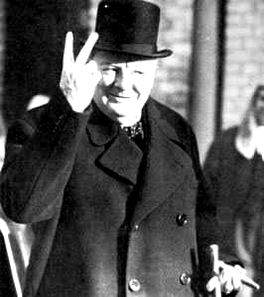
T H I N K T H R O U G H H I S T O RY: Summarizing
What were Churchill’s main points in his speech?

. . . It must be remembered that we are in the preliminary stage of one of the greatest battles in history, that we are in action at many points in Norway and in Holland, that we have to be prepared in the Mediterranean, that the air battle is continuous and that many preparations have to be made here at home. In this crisis I hope I may be pardoned if I do not address the House at any length today. I hope that any of my friends and colleagues, or former colleagues, who are affected by the political reconstruction, will make all allowance for any lack of ceremony with which
it has been necessary to act. I would say to the House, as I said to those who have joined the Government: “I have nothing to offer but blood, toil, tears and sweat.”
We have before us an ordeal of the most grievous kind. We have before us many, many long months of struggle and of suffering. You ask, what is our policy? I will say: It is to wage war, by sea, land and air, with all our might and with all the strength that God can give us: to wage war against a monstrous tyranny, never surpassed in the dark, lamentable catalogue of human crime. That is our policy. You ask, What is our aim? I can answer in one word: Victory—victory at all costs, victory in spite of all terror, victory, however long and hard the road may be; for without victory, there is no survival. Let that be realized; no survival for the British Empire;
no survival for all that the British Empire has stood for, no survival for the urge and impulse of the ages, that mankind will move forward towards its goal. But I take up my task with buoyancy and hope. I feel sure that our cause will not be suffered to fail among men. At this time I feel entitled to claim the aid of all, and I say,
“Come, then, let us go forward together with our united strength.”

Source: Excerpt from Blood, Toil, Tears and Sweat: The Speeches of Winston
Churchill, edited by David Cannandine (Boston: Houghton Mifflin, 1989)

